Homework Thirteen
Modals and Verb Phrase Diagramming
Exercise 1.
Identify any modals, semi-modals, or auxiliaries in these sentences.
Note: Not all uses of be, do, and have are auxiliary. Sometimes they are the main verb.
  - I could be reading.
- Could (modal), be (auxiliary)
  - I must be calm.
- Must (modal)
  - I did not leave on time.
- Did (auxiliary verb)
  - You might wait a long time.
- Might (modal)
  - I’ve gotta be me.
- Gotta (semi-modal) Have [I’ve] (aux)
  - The letter must not have been very serious.
- Must (modal)
- Have (auxiliary verb)
  - You should be running away from me!
- Should (modal)
- Be (auxiliary verb)
  - The after-party will be hosted by my sister.
- Will (modal)
- Be – (auxiliary verb)
Exercise 2.
Passive Voice, Auxiliaries, Modals, and Semi-Modals often allow for nuanced meaning about hypothetical cases, responsibility, and emphasis. For the five verbs below, craft a new sentence that provides nuanced and interesting meaning by adding one or more of these elements (passive voice, auxiliary, modal, semi-modal). You may use any tense or aspect.
Example: “prepare”

  - “analyze”
    - I will have analyzed the data carefully by Monday.
    - The data might have been analyzed incorrectly.
    - The paper was analyzed in scope by the Microsoft Team.
  - “allow”
    - I could allow the homework to be late.
    - The puppies were allowed to be outside by her.
    - She allowed the puppies to be outside.
    - Students might be allowed to retake the test.
  - “get”
    - I was gonna get around to it.
    - I might get to know who crashed the car.
    - I should have gotten there sooner.
- Tense: No Tense
- Aspect: Perfect
- Voice: Active
  - “be”
    - Todd may be rude.
    - The door has not been white in many years.
  - “do”
    - She used to do the annual triatholon but that was before she took an arrow to the knee.
    - I do not want to do that.
    - I have done everything I can to help you.

Exercise 3.
For the sentences on the following pages, create a diagram in the style we have been practicing in class. As shown in the video, you may branch your auxiliaries and modals off the main VP level or you may create a “Main Verb Phrase” (MVP) to keep the diagram more orderly. Note that these also test your ability to diagram complex and compound sentences.

- Charlie finally did discover the reason for the breakup after she had explored every possibility.

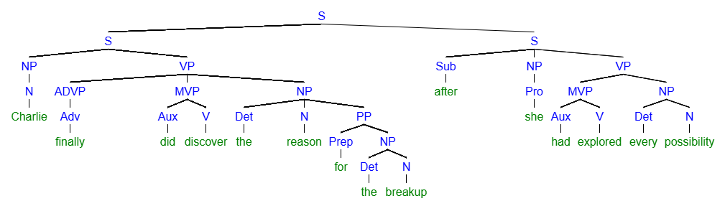
[S [S [NP [N Charlie]] [VP [ADVP [Adv finally]] [MVP [Aux did] [V discover]] [NP [Det the] [N reason] [PP [Prep for] [NP [Det the] [N breakup]]]]]] [S [Sub after] [NP [Pro she]] [VP [MVP [Aux had] [V explored]] [NP [Det every] [N possiblity]

- All those records could be broken by the Oklahoma City Thunder or the Cleveland Cavaliers.
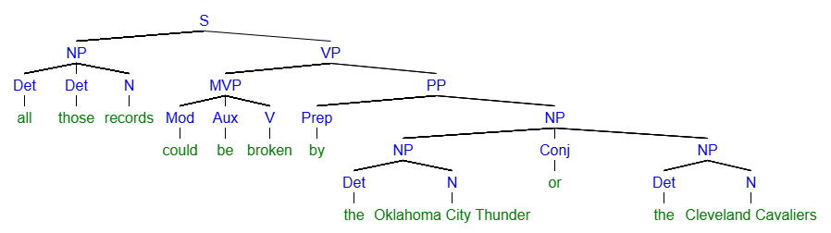
[S [NP [Det all] [Det those] [N records]] [VP [MVP [Mod could] [Aux be] [V broken]] [PP [Prep by] [NP [NP [Det the] [Oklahoma City Thunder]] [Conj or] [NP [Det the] [N Cleveland Cavaliers]

- The tailor might have been a rich man, but currently he is living in poverty.
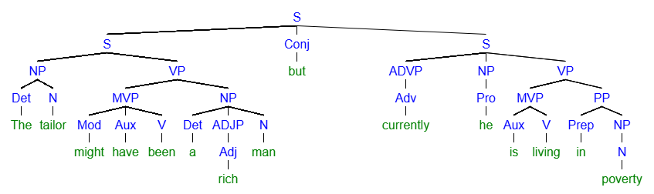
[S [S [NP [Det The] [N tailor]] [VP [MVP [Mod might] [Aux have] [V been]] [NP [Det a] [ADJP [Adj rich] [N man]]]]] [Conj but] [S [ADVP [Adv currently]] [NP [Pro he]][VP [MVP [Aux is] [V living]] [PP [Prep in] [NP [N poverty]

- Upon completion of the experiment, all the personal data will be deleted.
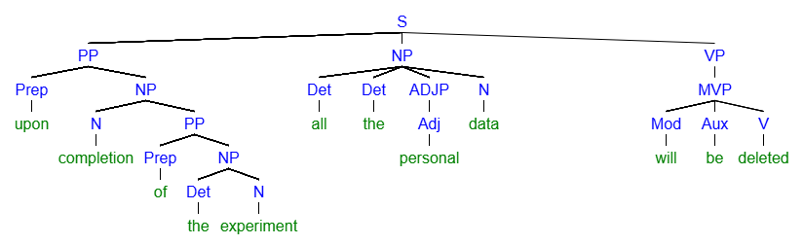
[S [PP [Prep upon] [NP [N completion] [PP [Prep of] [NP [Det the] [N experiment]]]]] [NP [Det all] [Det the] [ADJP [Adj personal]] [N data]] [VP [MVP [Mod will] [Aux be] [V deleted]

- Todd might have been kidding or could have been being serious.
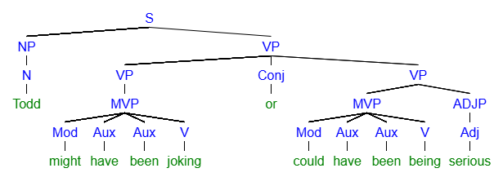
[S [NP [N Todd]] [VP [VP [MVP [Mod might] [Aux have] [Aux been] [V joking]]] [Conj or] [VP [MVP [Mod could] [Aux have] [V been]] [ADJP [Adj serious]

